IMAGES FOR ECLOGUE, part 2

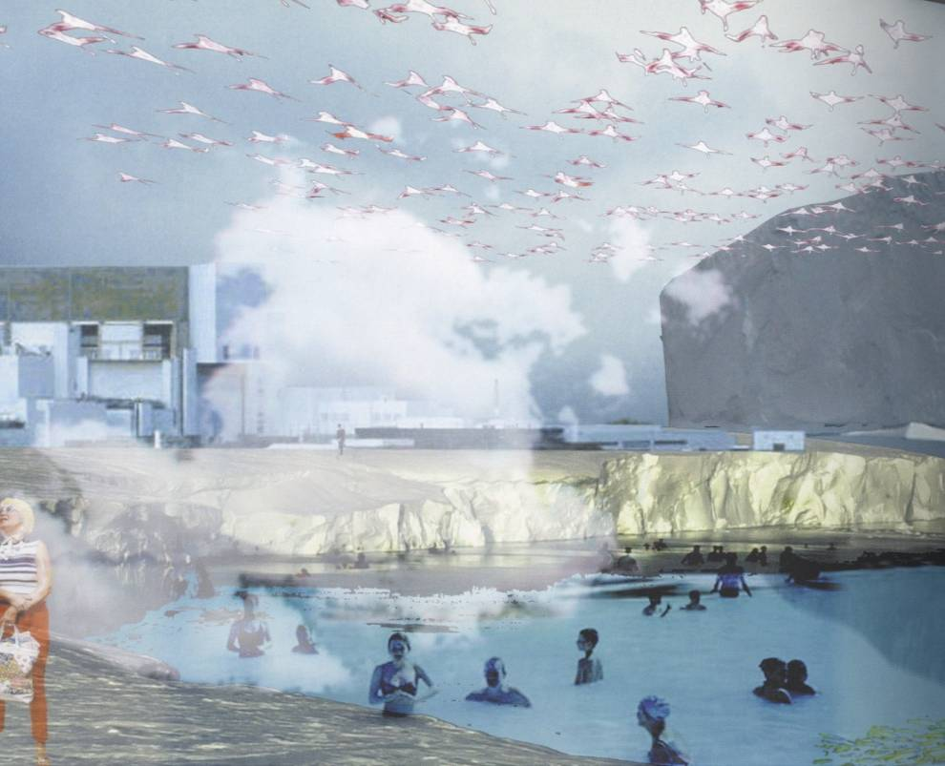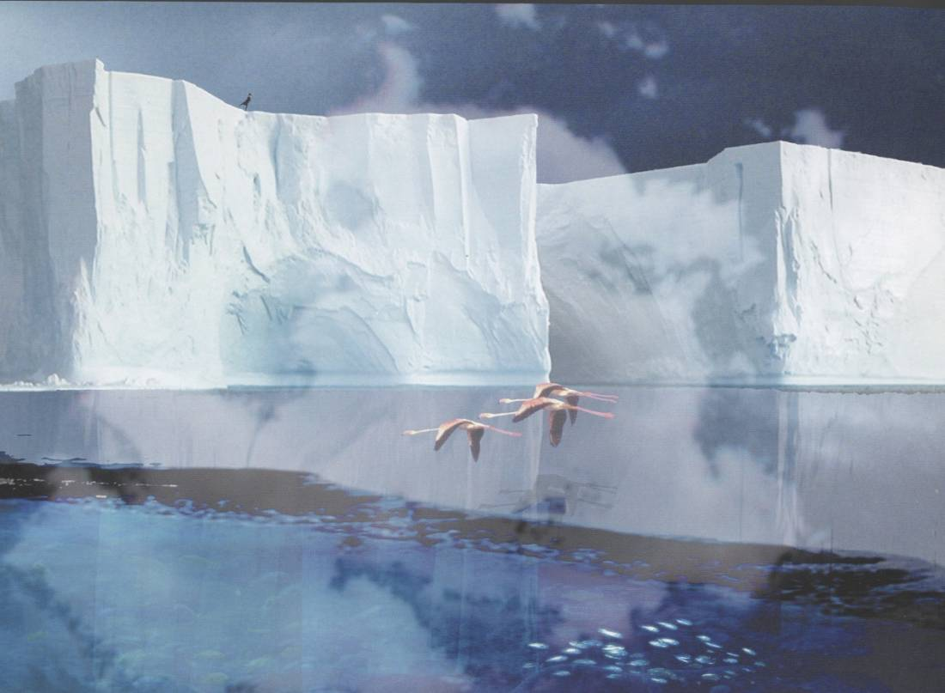

Figure 5: “Global Warming/Local Freezing” proposed by GROSS.MAX for the 600 Miles Exhibition, Glasgow, 2005.

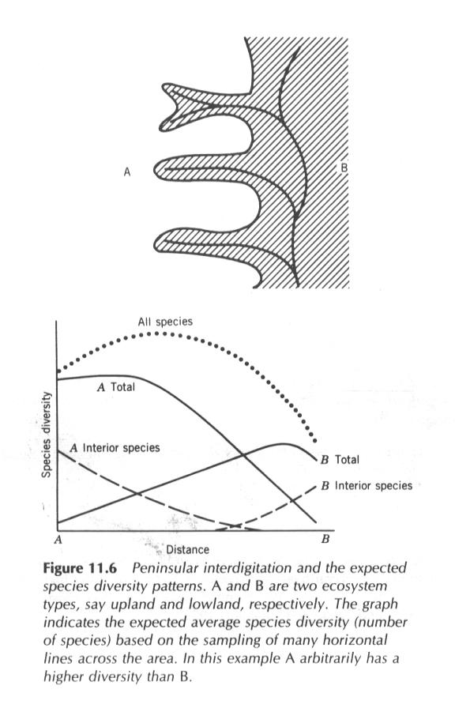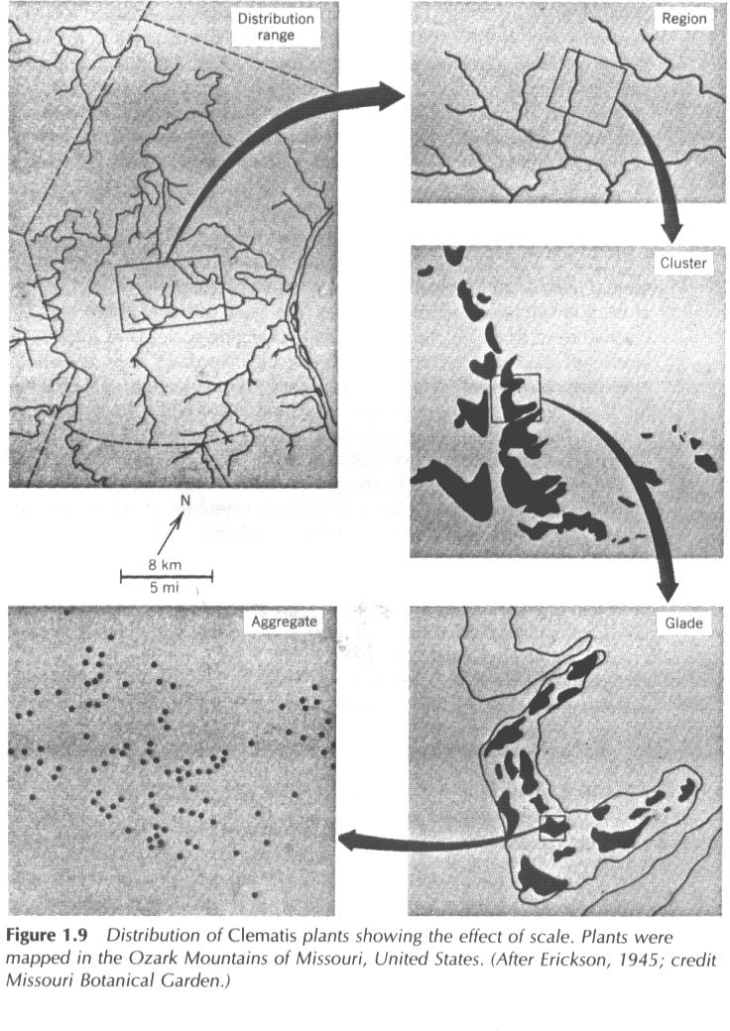

Figures 6 and 7: Diagrams from Landscape Ecologist Richard Forman’s research (from Land Mosaics: The Ecology of Landscape and Regions, R. Forman and E. O. Wilson. London: Cambridge University Press, 1995)
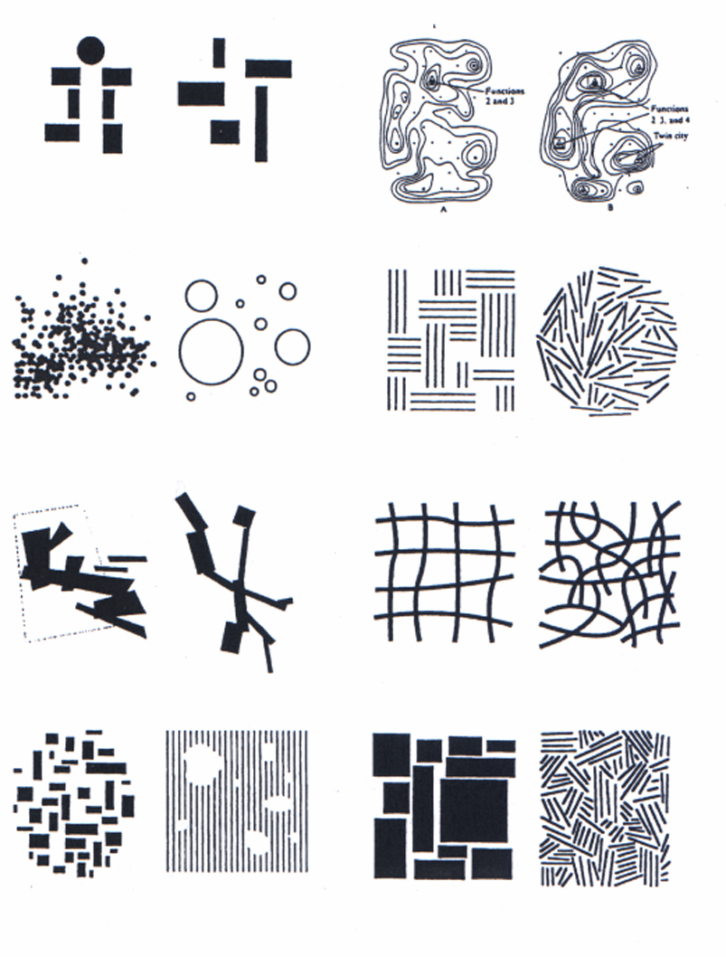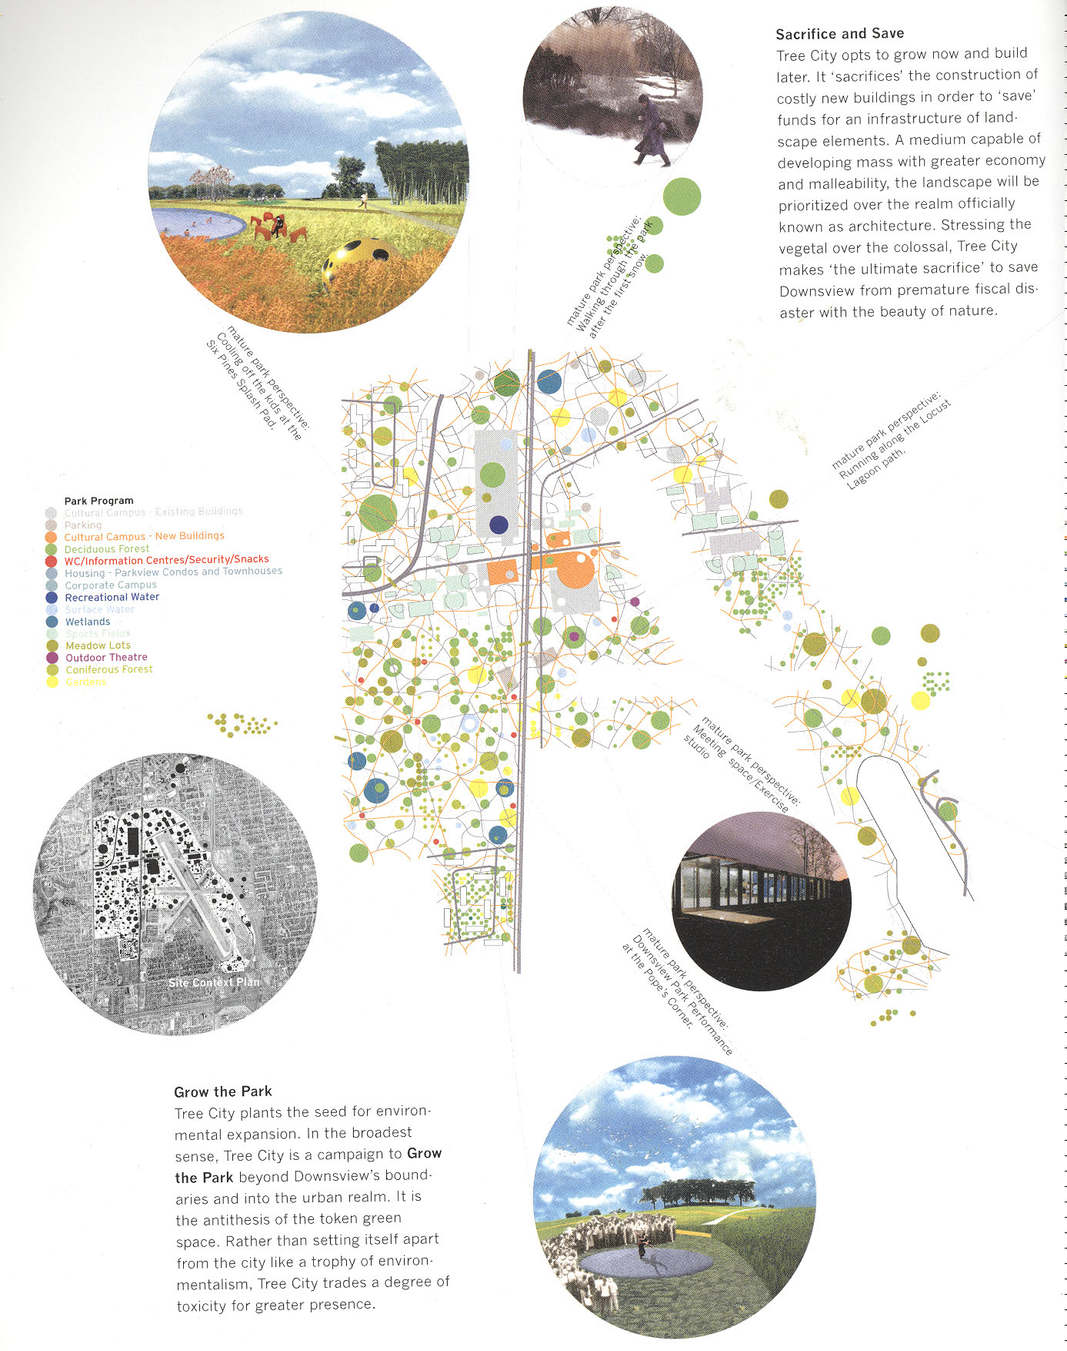

Figures 8 and 9: on left, field conditions diagrams from Stan Allen’s Points + Lines (1999). On right, Tree City diagram, OMA, Parc Downsview (2000, from CASE: Downsview, Czerniak).

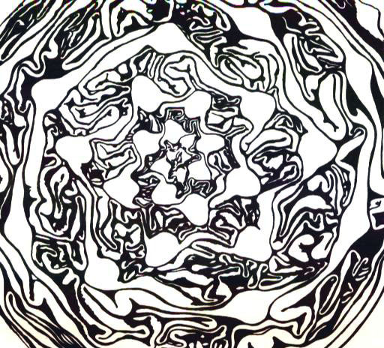 (FOA’s topo map for Downsview Park)

Figures 10 and 11: on left, cabbage head morphology (source: Li: Dynamic Form in Nature). On right, the topographical parametrics of FOA’s Parc Downsview proposal are derived from the ergonomics of bodies in recreational movement (2000, from CASE: Downsview, Czerniak)
.

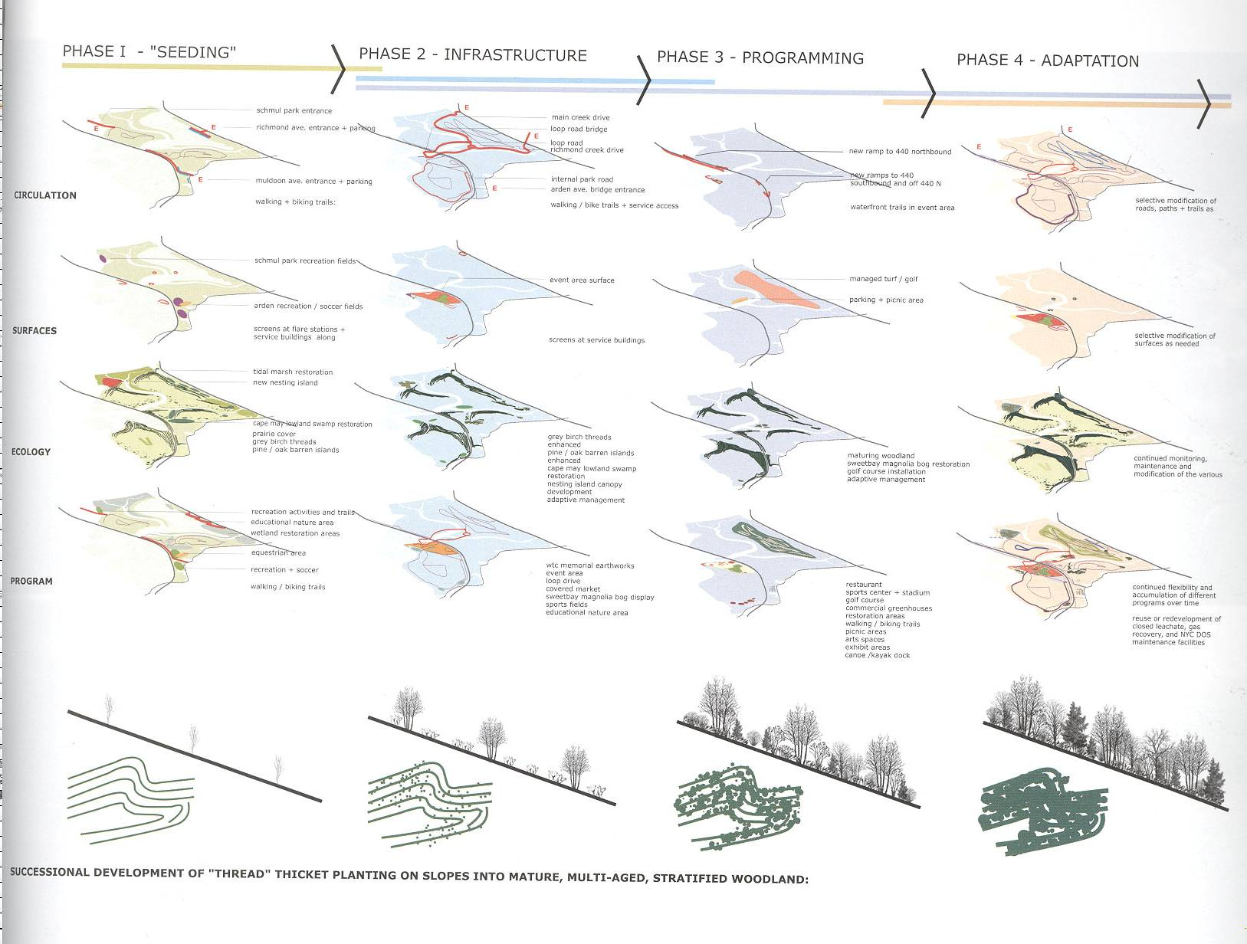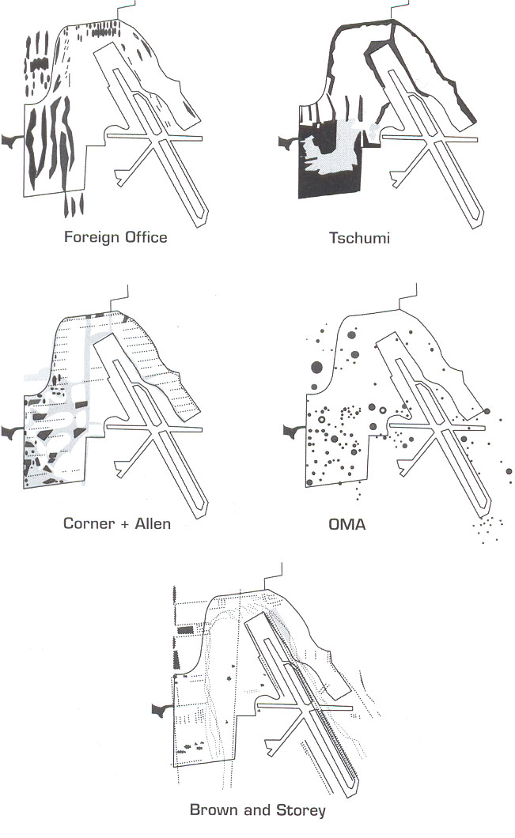

Figures 12 and 13: on left, Lifescape diagram from the Field Operations winning proposal for the Fresh Kills park competition (2001, from Praxis #4 you may want to rescan this image it’s crappy quality). On right, the ecological footprint of four of the finalist schemes for Parc Downsview (2000, from CASE: Downsview, Czerniak).

Figure 14: super-realist imagery by the Scottish landscape practice GROSS.MAX, 2005 (source: grossmax.com).

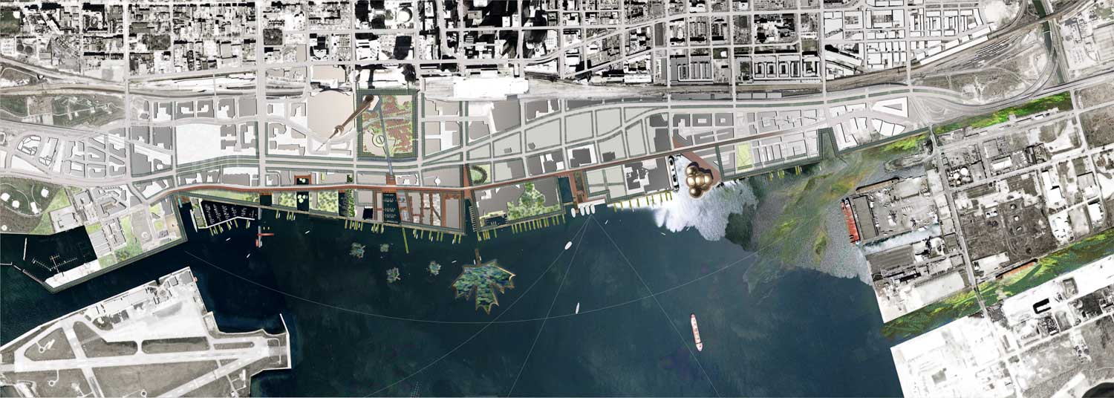

Figure 15: Extroverted, consensual and plural: West 8’s 2006 winning scheme for one portion of the Toronto Waterfront fuses social elements such as pedestrian routes, transit hubs and recreation staging with ecological components, including massive, floating maple leafs that house phytoremediating plant materials. Toward the upper right, the mouth of the Don River exaggerates the urban/environmental interface to capture the public’s attention for this “repository for undesirables” as a palpable metropolitan matter (image source: www.dtah.com/waterfront).

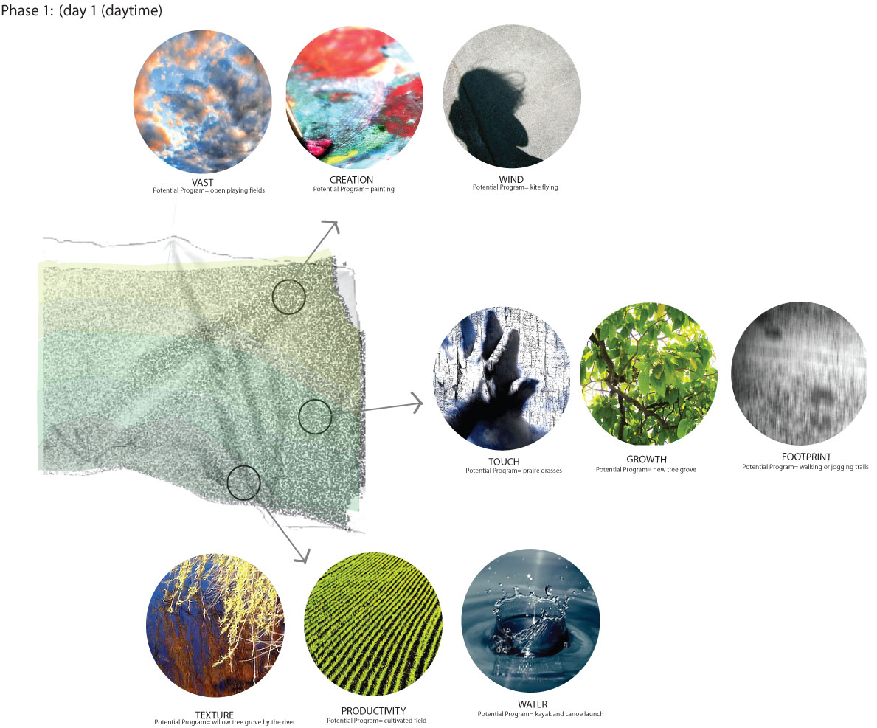

Location, information, sensation: Irishtown Bend competition, park proposal by Elizabeth Lagedroste (source: E. Lagedroste, 2007).

