IMAGES FOR ECLOGUE, part 1

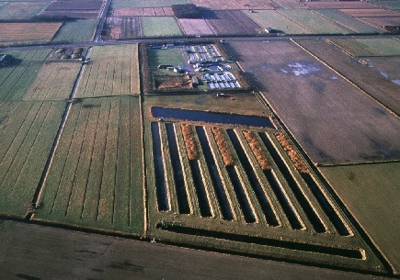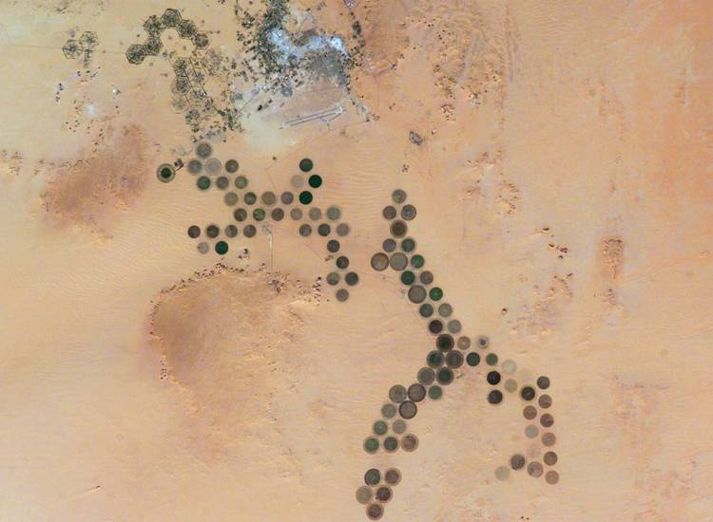
Figures 1 and 2: Land machines, a precursor of entrepreneurial environmentalism’s ecologically-based but consumer-oriented productivity, from left: fish hatchery (source: odnr.gov); on right, the Al Khufrah Oasis in southeastern Libya, as seen from the International Space Station (photo courtesy of the Image Science and Analysis Laboratory/NASA). In response to satellite imagery of the oasis, pruned.blogspot asks, “What will Google Earth tourists see when they point their vigilant eyes towards an electrified North Africa? Will they come upon vast plantations of coronal fields, perfect geometries arrayed in similarly perfect arrangement, irrespective of terrain but nevertheless finely attuned to the sky? And what about the people on the ground? Where once was desert, might they now enjoy newly sprouted oases, which are fed with water from solar-powered desalination plants? An Emerald Necklace of Olmstedian design inscribed in the Saharan landscape?” (pruned.blogspot).

Figure 3: BioMass Transit, InFlux, Envisioning Gateways competition (2007)
BioMass Transit explores a scalable strategy: the decline of the world’s biomass is indexed globally while the public is incorporated locally as a funding source. In the New York metro region, riders swipe a “biomass transit card” each time they ride the bus or subway, putting five cents toward nearby marshland and forestry conservation efforts. The public collaborates in the socio-ecology as part of their every day routine, using remote purchasing power to increase water and air quality and reduce the region’s dependence on outside energy sources by creating more harvestable biomass. Collective benefit is derived from pro-active land management practices; individuals encounter a productive urbanism diversely receptive to the affective properties of an enhanced nature that serves multiple ends. Does the scheme emanate optimism and altruism? Or the urgency of survival, the most innate and selfish of instincts?

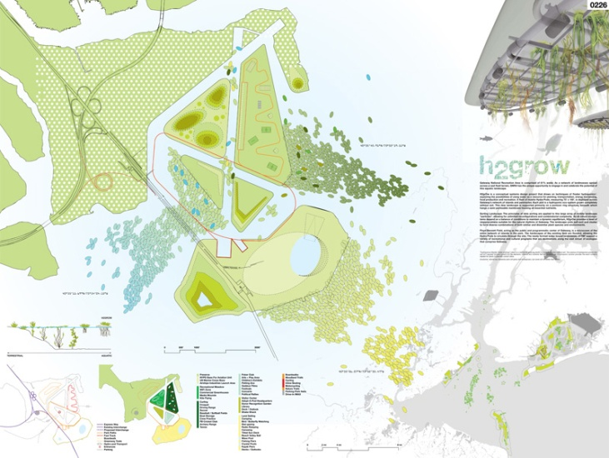
Figure 4: H2Grow, F. Gesualdi & H. Eber, Envisioning Gateways competition (2007)
From the design team’s project description: “H2grOw is a conceptual systems design project that draws on techniques of floater hydroponics, exploring the possibilities of using water as a resource for planting, transportation, energy harnessing, food production and recreation. A fleet of mobile Hydro Pods, measuring 75' x 140', is deployed across Gateway's network of islands and peninsulas. Each pod is a hydroponic eco-system grown completely without soil. This new landscape is supported primarily on a pontoon ring structure, beneath which hangs a semi permeable membrane housing all essential nutrients. …[It is a] Sorting Landscape: the principles of data sorting are applied to this large array of mobile landscape "particles", allowing for unlimited reconfigurations and combinatorial complexity” (www.valalen.org/gateway).

